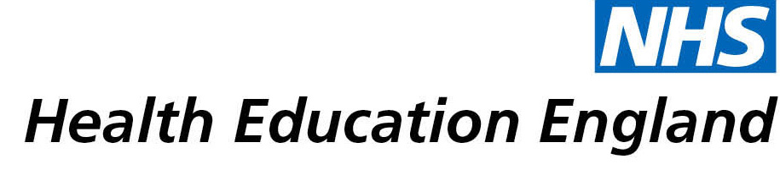

Library and Knowledge Services case study

Homerton University Hospital NHS Foundation Trust, Newcomb Library: Impact of library expertise on the development and running of a Medical Humanities course

Date Summer 2019

Reason for enquiry
We planned to set up a new medical humanities teaching module in paediatrics and asked the library for help with book ideas and support for starting a medical humanities themed book club in the department.

(Medical humanities is the study of the Patient and Doctor Journey through narrative, art and film. We wanted to expand our teaching programme to incorporate analysis of relevant literature and arts, to improve patient care and staff well-being and increase awareness of medical humanities).

In particular we wanted to consider if and what we can learn from literature so we asked for help from the library.

What the knowledge and library specialist did
The librarian was very helpful and supported us to set up the teaching. She gave us information about resources available.

Also we discussed the relevant books that were available and the library sent a link to a reading list they had developed and also let us know about new books they had purchased that would support our curriculum:

The Immortal Life of Henrietta Lacks
The Novel Cure
Wonder
What Patients Say, What Doctors Hear
Adventures in Human Being

The start of our course coincided with Libraries Week and tied in with the wellbeing theme so medical humanities fitted in well.

The library staff are particularly knowledgeable about graphic novels, which was instrumental in increasing our awareness of this area and which books the library had, for us to prepare for the teaching session on graphic novels. These are very relevant in both patient and doctor stories within medical humanities.

In addition, the librarian explored book sets for the book club and contacted the Hackney Public Library service to borrow multiple copies of books for us to use at a book club.

The librarian attended most of the teaching sessions and was able to contribute book suggestions, bring along relevant books from the library and contribute to the discussions taking place at the sessions.

Impact of input from the library and knowledge service
The impact was tremendous. We could not have run the module (six interactive sessions) to a high standard, without the help of the library.

Immediate Impact
The feedback from the team was excellent. We set up a notice board in the department for resources, including those sent to us from the library.

We have submitted an abstract of our work to a conference.

We were encouraged and motivated to run the medical humanities sessions again.

Probable future Impact
This teaching programme initiated a dialogue in the department and increased awareness of the subject, which led to a better understanding of patient journeys, doctor stories, empathy and well-being, all of which would have a positive impact on patient care and staff well-being. After a pause due to COVID-19, we hope to run the medical humanities sessions again.

Submission by:
Name: Cauvery Pal
Job Title: Consultant Paediatrician
Email: cauvery.pal@nhs.net

For further information on how you can get similar support contact your local NHS library and knowledge service.

